SQL Exercises, Practice– SUBQUERIES

**Department Table:**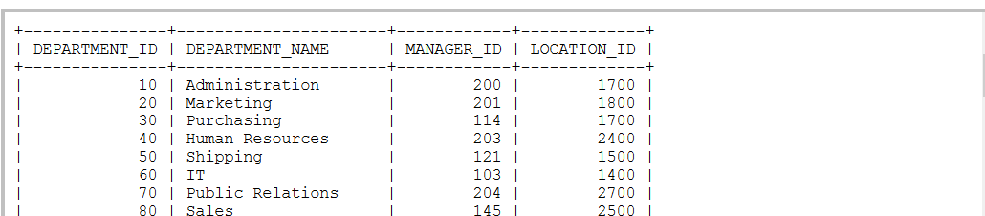

**Employee Table:**

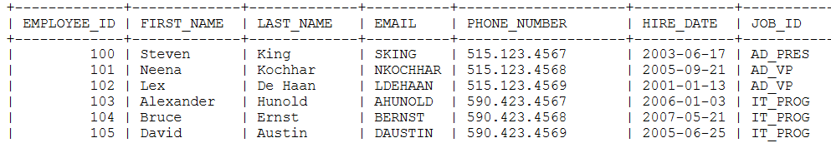

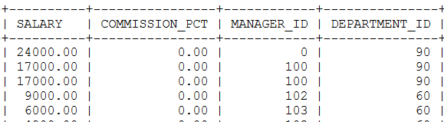

**Country Table:**

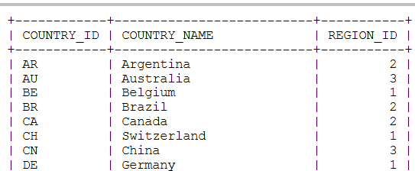

**Location Table:**

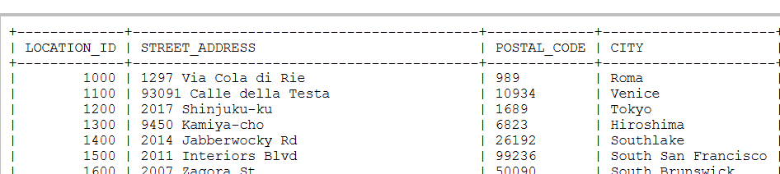

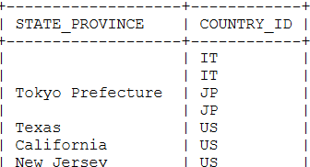

**Jobs:**

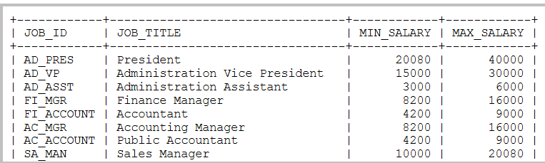

**Job History:**

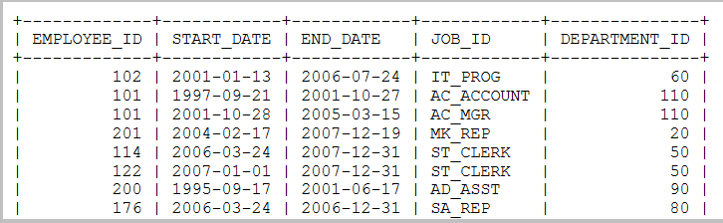

**1.** Write a query to display the name ( first name and last name ) for those employees who gets more salary than the employee whose ID is 163.

**2.** Write a query to display the name ( first name and last name ), salary, department id, job id for those employees who works in the same designation as the employee works whose id is 169.

**3.** Write a query to display the name ( first name and last name ), salary, department id for those employees who earn such amount of salary which is the smallest salary of any of the departments.

**4.** Write a query to display the employee id, employee name (first name and last name ) for all employees who earn more than the average salary.

**5.** Write a query to display the employee name ( first name and last name ), employee id and salary of all employees who report to Payam.

**6.** Write a query to display the department number, name ( first name and last name ), job and department name for all employees in the Finance department.

**7.** Write a query to display all the information of an employee whose salary and reporting person id is 3000 and 121 respectively.

**8.** Display all the information of an employee whose id is any of the number 134, 159 and 183.

**9.** Write a query to display all the information of the employees whose salary is within the range 1000 and 3000.

**10.** Write a query to display all the information of the employees whose salary is within the range of smallest salary and 2500.

**11.** Write a query to display all the information of the employees who does not work in those departments where some employees works whose manager id within the range 100 and 200.

**12.** Write a query to display all the information for those employees whose id is any id who earn the second highest salary.

**13.** Write a query to display the employee name( first name and last name ) and hiredate for all employees in the same department as Clara. Exclude Clara.

**14.** Write a query to display the employee number and name( first name and last name ) for all employees who work in a department with any employee whose name contains a T.

**15.** Write a query to display the employee number, name( first name and last name ), and salary for all employees who earn more than the average salary and who work in a department with any employee with a J in their name.

**16.** Display the employee name( first name and last name ), employee id, and job title for all employees whose department location is Toronto.

**17.** Write a query to display the employee number, name( first name and last name ) and job title for all employees whose salary is smaller than any salary of those employees whose job title is MK_MAN.

**18.** Write a query to display the employee number, name( first name and last name ) and job title for all employees whose salary is smaller than any salary of those employees whose job title is MK_MAN. Exclude Job title MK_MAN.

**19.** Write a query to display the employee number, name( first name and last name ) and job title for all employees whose salary is more than any salary of those employees whose job title is PU_MAN. Exclude job title PU_MAN.

**20.** Write a query to display the employee number, name( first name and last name ) and job title for all employees whose salary is more than any average salary of any department.

**21.** Write a query to display the employee name( first name and last name ) and department for all employees for any existence of those employees whose salary is more than 3700.

**22.** Write a query to display the department id and the total salary for those departments which contains at least one employee.

**23.** Write a query to display the employee id, name ( first name and last name ) and the job id column with a modified title SALESMAN for those employees whose job title is ST_MAN and DEVELOPER for whose job title is IT_PROG.

**24.** Write a query to display the employee id, name ( first name and last name ), salary and the SalaryStatus column with a title HIGH and LOW respectively for those employees whose salary is more than and less than the average salary of all employees.

**25.** Write a query to display the employee id, name ( first name and last name ), SalaryDrawn, AvgCompare (salary - the average salary of all employees) and the SalaryStatus column with a title HIGH and LOW respectively for those employees whose salary is more than and less than the average salary of all employees.

**26.** Write a subquery that returns a set of rows to find all departments that do actually have one or more employees assigned to them.

**27.** Write a query that will identify all employees who work in departments located in the United Kingdom.

**28.** Write a query to identify all the employees who earn more than the average and who work in any of the IT departments.

**29.** Write a query to determine who earns more than Mr. Ozer.

**30.** Write a query to find out which employees have a manager who works for a department based in the US.

**31.** Write a query which is looking for the names of all employees whose salary is greater than 50% of their department’s total salary bill.

**32.** Write a query to get the details of employees who are managers.

**33.** Write a query to get the details of employees who manage a department.

**34.** Write a query to display the employee id, name ( first name and last name ), salary, department name and city for all the employees who gets the salary as the salary earn by the employee which is maximum within the joining person January 1st, 2002 and December 31st, 2003.

**35.** Write a query in SQL to display the department code and name for all departments which located in the city London.

**36.** Write a query in SQL to display the first and last name, salary, and department ID for all those employees who earn more than the average salary and arrange the list in descending order on salary.

**37.** Write a query in SQL to display the first and last name, salary, and department ID for those employees who earn more than the maximum salary of a department which ID is 40.

**38.** Write a query in SQL to display the department name and Id for all departments where they located, that Id is equal to the Id for the location where department number 30 is located.

**39.** Write a query in SQL to display the first and last name, salary, and department ID for all those employees who work in that department where the employee works who hold the ID 201.

**40.** Write a query in SQL to display the first and last name, salary, and department ID for those employees whose salary is equal to the salary of the employee who works in that department which ID is 40.

**41.** Write a query in SQL to display the first and last name, and department code for all employees who work in the department Marketing.

**42.**Write a query in SQL to display the first and last name, salary, and department ID for those employees who earn more than the minimum salary of a department which ID is 40.

**43.** Write a query in SQL to display the full name,email, and designation for all those employees who was hired after the employee whose ID is 165.

**44.** Write a query in SQL to display the first and last name, salary, and department ID for those employees who earn less than the minimum salary of a department which ID is 70.

**45.** Write a query in SQL to display the first and last name, salary, and department ID for those employees who earn less than the average salary, and also work at the department where the employee Laura is working as a first name holder.

**46.** Write a query in SQL to display the first and last name, salary and department ID for those employees whose department is located in the city London.

**47.** Write a query in SQL to display the city of the employee whose ID 134 and works there.

**48.** Write a query in SQL to display the the details of those departments which max salary is 7000 or above for those employees who already done one or more jobs.

**49.** Write a query in SQL to display the detail information of those departments which starting salary is at least 8000.

**50.** Write a query in SQL to display the full name (first and last name) of manager who is supervising 4 or more employees.

**51.** Write a query in SQL to display the details of the current job for those employees who worked as a Sales Representative in the past.

**52.** Write a query in SQL to display all the infromation about those employees who earn second lowest salary of all the employees.

**53.** Write a query in SQL to display the details of departments managed by Susan.

**54.** Write a query in SQL to display the department ID, full name (first and last name), salary for those employees who is highest salary drawar in a department.

**55.** Write a query in SQL to display all the information of those employees who did not have any job in the past.